Report

**Train Data Visualization (with augmentation)**

|  |  |  |
| --- | --- | --- |
|  |  |  |
|  |  |  |

**Valid Data Visualization (without augmentation)**

|  |  |  |
| --- | --- | --- |
|  |  |  |
|  |  |  |

**Training Curves**

Epoch 1/100

100%|██████████| 7330/7330 [29:17<00:00, 4.17it/s, Loss=9.517, mAP=0.019]

100%|██████████| 155/155 [01:10<00:00, 2.21it/s, Loss=8.511, mAP=0.029]

Epoch 2/100

100%|██████████| 7330/7330 [30:32<00:00, 4.00it/s, Loss=7.583, mAP=0.068]

100%|██████████| 155/155 [00:56<00:00, 2.74it/s, Loss=7.207, mAP=0.066]

Epoch 3/100

100%|██████████| 7330/7330 [30:13<00:00, 4.04it/s, Loss=6.845, mAP=0.108]

100%|██████████| 155/155 [01:02<00:00, 2.49it/s, Loss=6.641, mAP=0.090]

…

|  |  |
| --- | --- |
|  |  |

**Valid Performance (trained yolo_v8_n)**

|  |  |
| --- | --- |
|  |  |
|  |  |
|  |  |

**Valid Performance (official v8_m)**

|  |  |
| --- | --- |
|  |  |
|  |  |
|  |  |

**GUI**

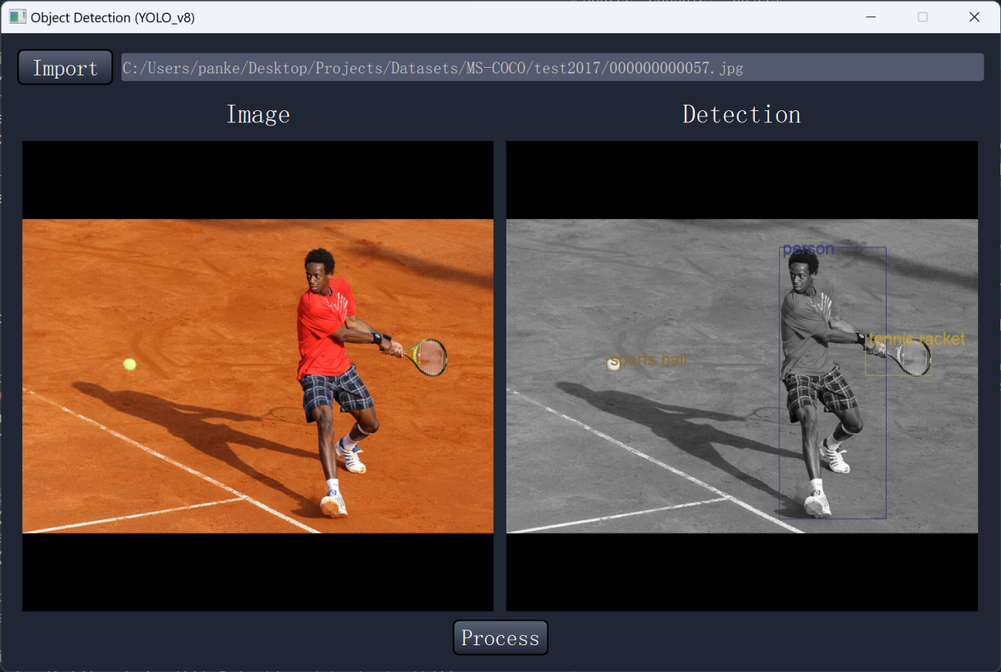

User Manual:

1. The “import” to import an image.
2. Then press “Process” button to generate a Detection map.